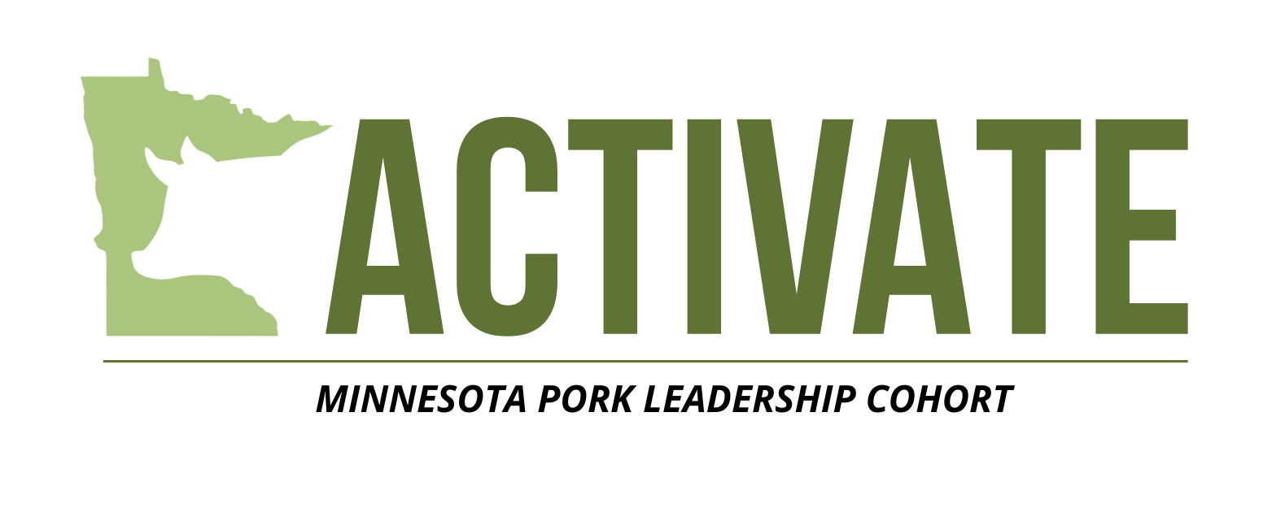

Applications are due to Kate Maddock by June 1, 2025. Please email or scan to kate@mnpork.com or mail to the Minnesota Pork Office (151 St Andrews Ct STE 810, Mankato, MN 56001).

Name: _______________________________________________________
Email Address: _______________________________________________
Phone Number: ______________________________________________
Mailing Address: ______________________________________________
County: _____________________________________________________

- Briefly describe your background in the pork industry.

- List any involvement with Minnesota Pork, agriculture or industry-related organizations, or community groups. (Please include roles and dates, if applicable.)

- Why are you interested in participating in Activate?

- What do you hope to learn or gain through this 18-month program?

- How do you plan to use what you learn to support the future of the Minnesota Pork Industry?

- What excites you about the future of the pork industry in Minnesota?

- Describe a time you took initiative or leadership – at work, in your community, or another setting?

- How do you define leadership?

- How did you hear/learn about Activate?

References
Please provide two references who can speak to your passion, work ethic, and leadership qualities. These individuals may be employers, mentors, colleagues, or community leaders who are familiar with your character and involvement.

Reference #1
Name: _______________________________________________
Relationship to you: ___________________________________
Phone Number: _______________________________________
Email Address: ________________________________________

Reference #2
Name: _______________________________________________
Relationship to you: ___________________________________
Phone Number: _______________________________________
Email Address: ________________________________________
Acknowledgement of Commitment
By signing or typing my name below, I acknowledge that I understand the expectations of the Activate program. I commit to attending all six in-person sessions over the next 18 months, including travel as needed, and actively participating in discussions, activities, and all aspects of the program. I understand that full engagement is essential to the success of my experience and the program.
Signature (typed name): ____________________________ Date: ___________________

Activate Session Schedule:
Session 1 – Minnesota Pork Office (Mankato, MN) – July 8-9, 2025 (2 days)
Session 2 – NPB/NPPC Offices (Des Moines, IA) – November/December 2025 (2 days)
Session 3 – MPPA Day on the Hill (St. Paul, MN) – February/March 2026 (2 days)
Session 4 – Content decided by Activate class – April 2026
Session 5 – Content decided by Activate class – July 2026
Session 6 – Washington D.C. Trip – November/December 2026 (3-4 days)
Graduation – Minnesota Pork Congress (Mankato, MN) – February 2027 (1 day)

If you have questions about Activate: Minnesota Pork Leadership Cohort or the application, please contact Kate Maddock at kate@mnpork.com or 507-901-0993.

